**Herramientas Básicas**

Fuente: J.E Hopcroft, J.D. Ullman. Introduction to Automata Theory, Languages, and Computation, Addison-Wesley, (1979), pp. 10-11

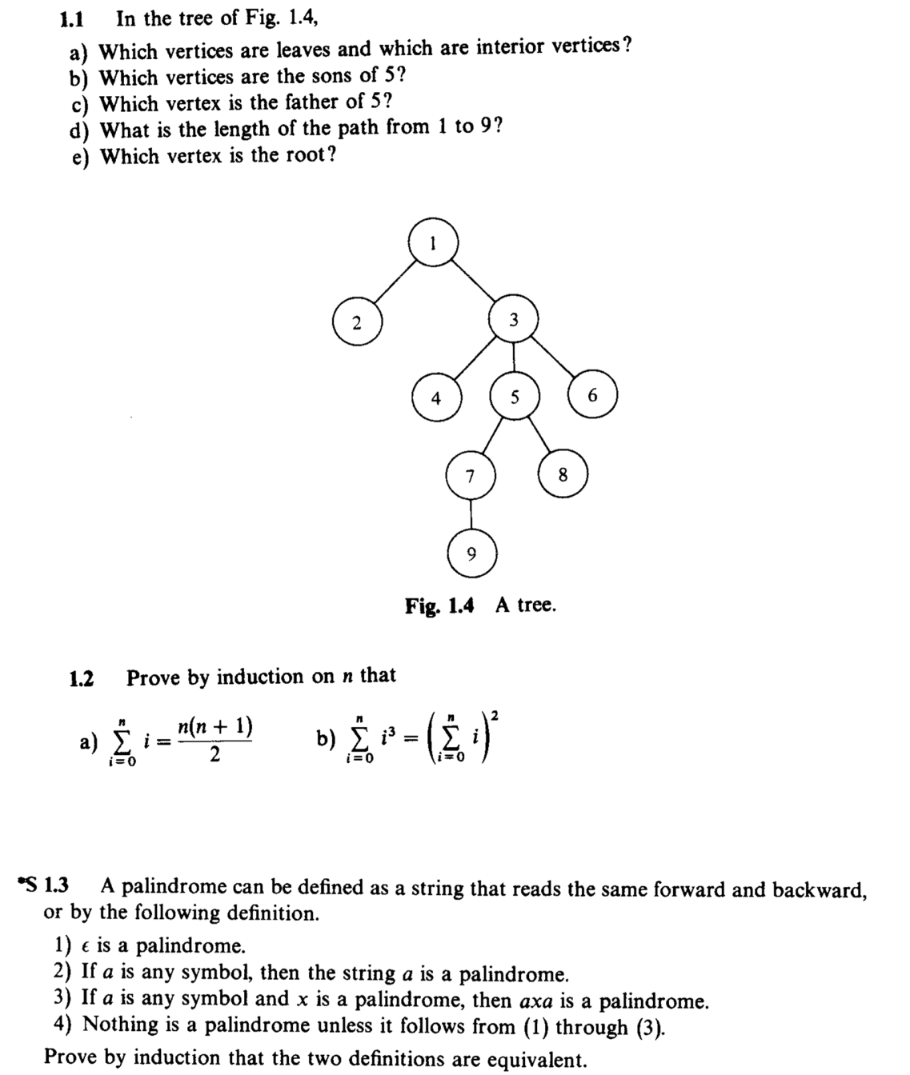

1. *Which vertices are leves and which are interior vertices?*
   1. Leaves: 2,4,6,8,9.
   2. Interior: 1,3,5,7.
2. *Which vertices are the sons of 5?*
   1. Sons of 5: 7,8.
3. *Which vertex is the father of 5?*
   1. Father of 5: 3.
4. *What is the length of the path from 1 to 9?*
   1. Length path from 1 to 9: 4.
5. *Which vertex is the root?*
   1. Root: 1.

**1.2.- Prove by induction that N on:**

